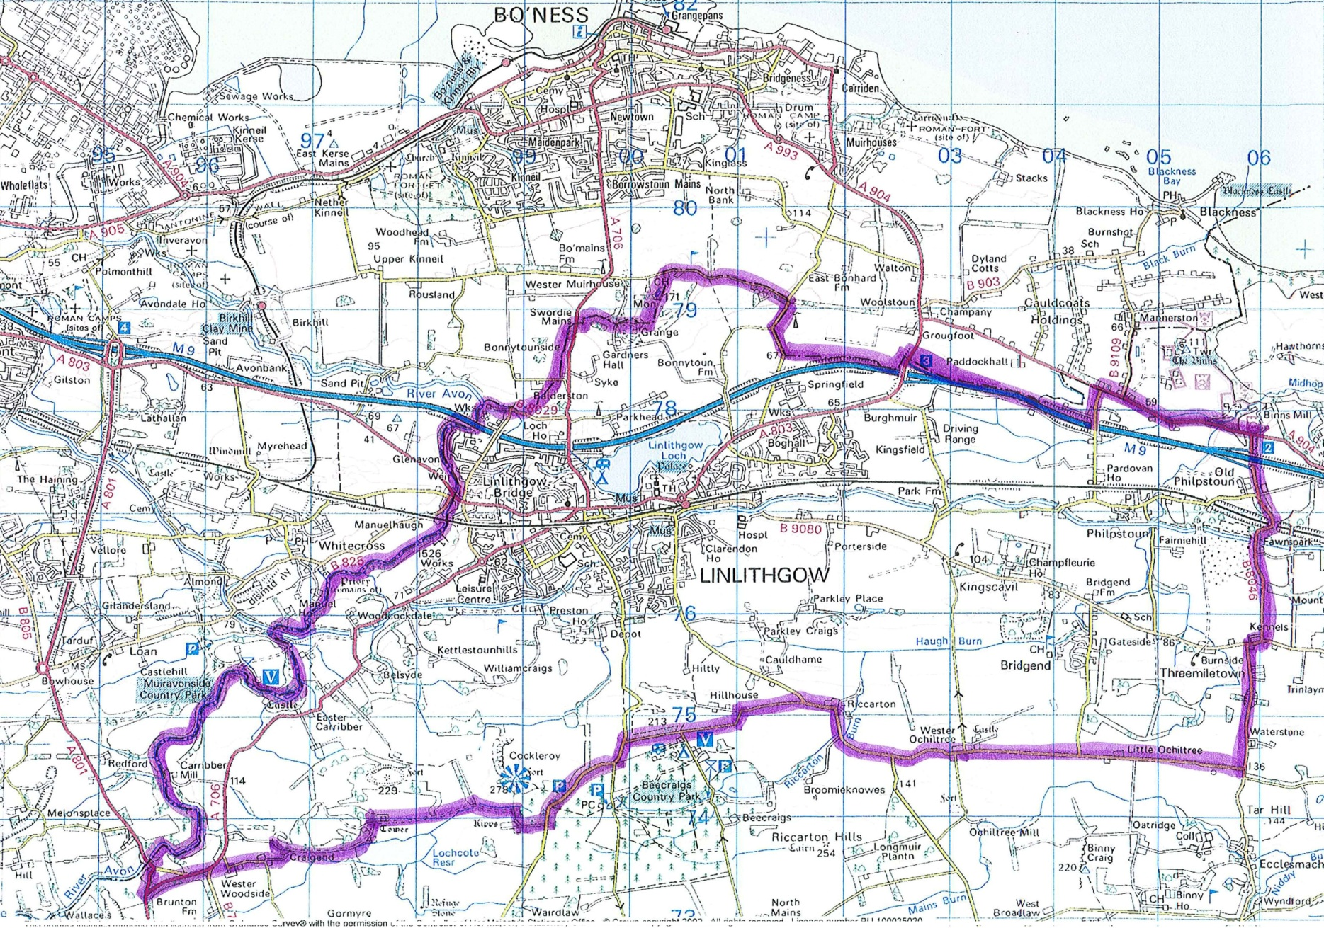
Boundary Definition:
"From the junction of the A801 and A706 along the A801 to the River Avon, then by the boundary between West Lothian and Falkirk to the A904, along the A904 and B8046 to Waterstone and minor roads west past Little Ochiltree, Wester Ochiltree, Riccarton, Hillhouse, Kipps, Craigend, and Wester Woodside to the A706, then along the A706 to the A801"

Please see the noticeboard at the main door for a larger map of the area

